FEDERAL STATE AUTONOMOUS EDUCATIONAL INSTITUTION OF HIGHER EDUCATION

ITMO UNIVERSITY

Report

on the practical Lab 3

“*Queue Model*”

Performed by

*Abizer Safdari*

*J41321c/J4134c*

St. Petersburg

2021

# Task

* Implement and compare all (four) models (by average queue size, total working etc.)
* Draw server's dynamic through the time (for dynamic queues)

# Experiment results

Run parameters.

maxAngents = 100

arrivalRateMin = 0

arrivalRateMax = 3

service_xk = np.arange(5) + 1

service_pk = (0.3, 0.2, 0.1, 0.25 ,0.15)

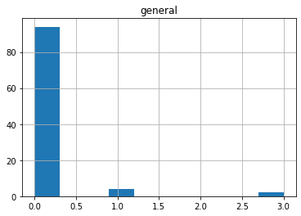

Fig 1. General queue method waiting time relatively to queue size

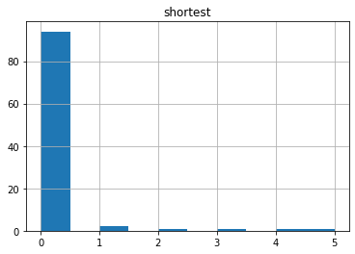

Fig 2. Shortest queue method waiting time relatively to queue size

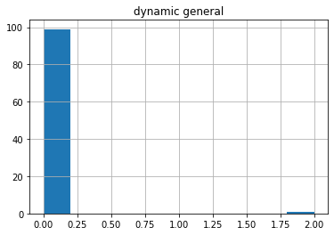

Fig 3. General queue method with dynamic servers count waiting time relatively to queue size

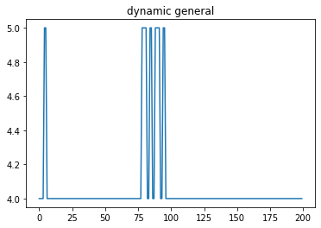

Fig 4. General queue method with dynamic servers count servers count changing

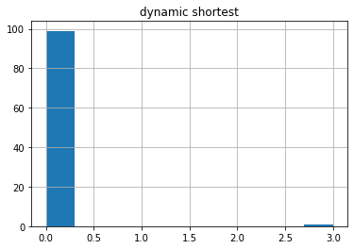

Fig 5. Shortest queue method with dynamic servers count waiting time relatively to queue size

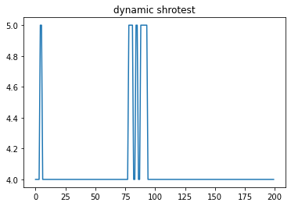

Fig 6. Shortest queue method with dynamic servers count changing

Methods comparison:

1. general queue
2. shortest queue
3. Dynamic general queue (num of server 4 or 5)
4. Dynamic shortest queue(num of server 4 or 5)

Average waiting time Probability that a customer has to wait

0 0.10 0.06

1 0.16 0.06

2 0.02 0.01

3 0.03 0.01

Probability of an Idle server Average service time

0 0.668639 2.82

1 0.682353 2.86

2 0.650888 2.79

3 0.643275 2.81

Average time between arrivals Average waiting time for those who wait

0 1.656566 1.666667

1 1.666667 2.666667

2 1.656566 2.000000

3 1.676768 3.000000

Average time a customer spends in the system

0 2.92

1 3.02

2 2.81

3 2.84

Average time a customer spends in the system (alternative)

0 2.92

1 3.02

2 2.81

3 2.84

maxAngents = 1000

arrivalRateMin = 0

arrivalRateMax = 3

service_xk = np.arange(8) + 1

service_pk = (0.05, 0.15, 0.1, 0.25 ,0.05, 0.2,0.1,0.1)

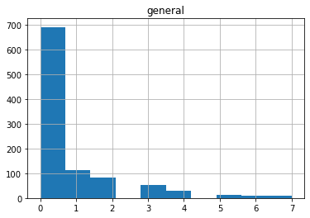

Fig 7. General queue method waiting time relatively to queue size

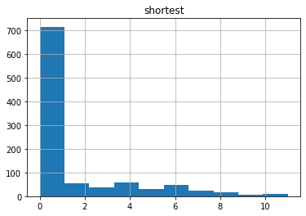

Fig 8. Shortest queue method waiting time relatively to queue

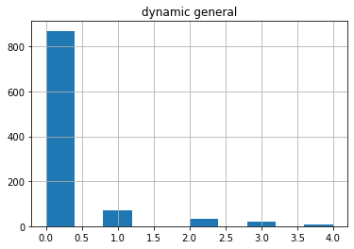

Fig 9. General queue method with dynamic servers count waiting time relatively to queue size

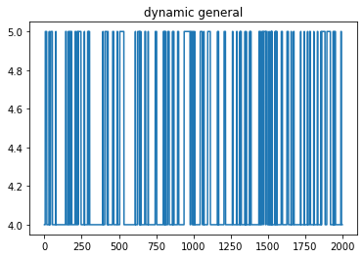

Fig 10. General queue method with dynamic servers count servers count changing

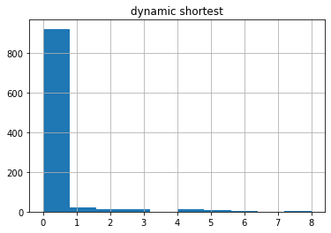

Fig 11. Shortest queue method with dynamic servers count waiting time relatively to queue size

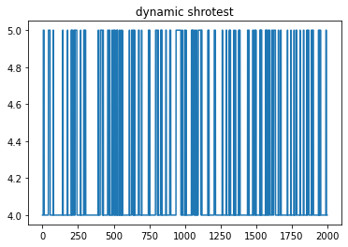

Fig 12. Shortest queue method with dynamic servers count changing

Method comparison:-

Average waiting time Probability that a customer has to wait \

0 0.739 0.308

1 1.398 0.339

2 0.225 0.130

3 0.232 0.077

Probability of an Idle server Average service time \

0 1.998048 4.608

1 2.006527 4.606

2 2.031128 4.674

3 1.958678 4.654

Average time between arrivals Average waiting time for those who wait \

0 1.530531 2.399351

1 1.523524 4.123894

2 1.537538 1.730769

3 1.568569 3.012987

Average time a customer spends in the system \

0 5.347

1 6.004

2 4.899

3 4.886

Average time a customer spends in the system (alternative)

0 5.347

1 6.004

2 4.899

3 4.886